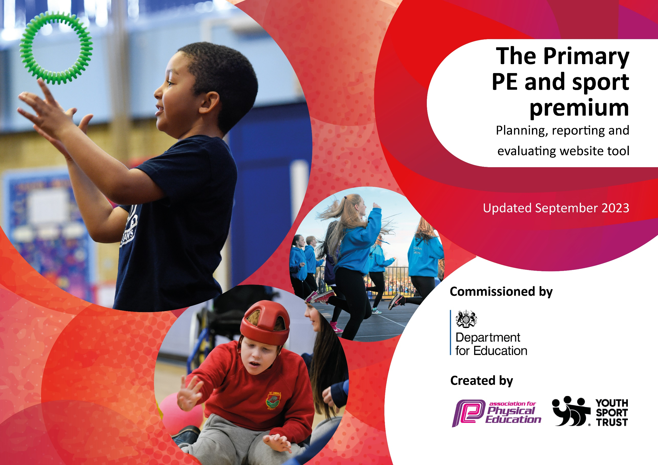

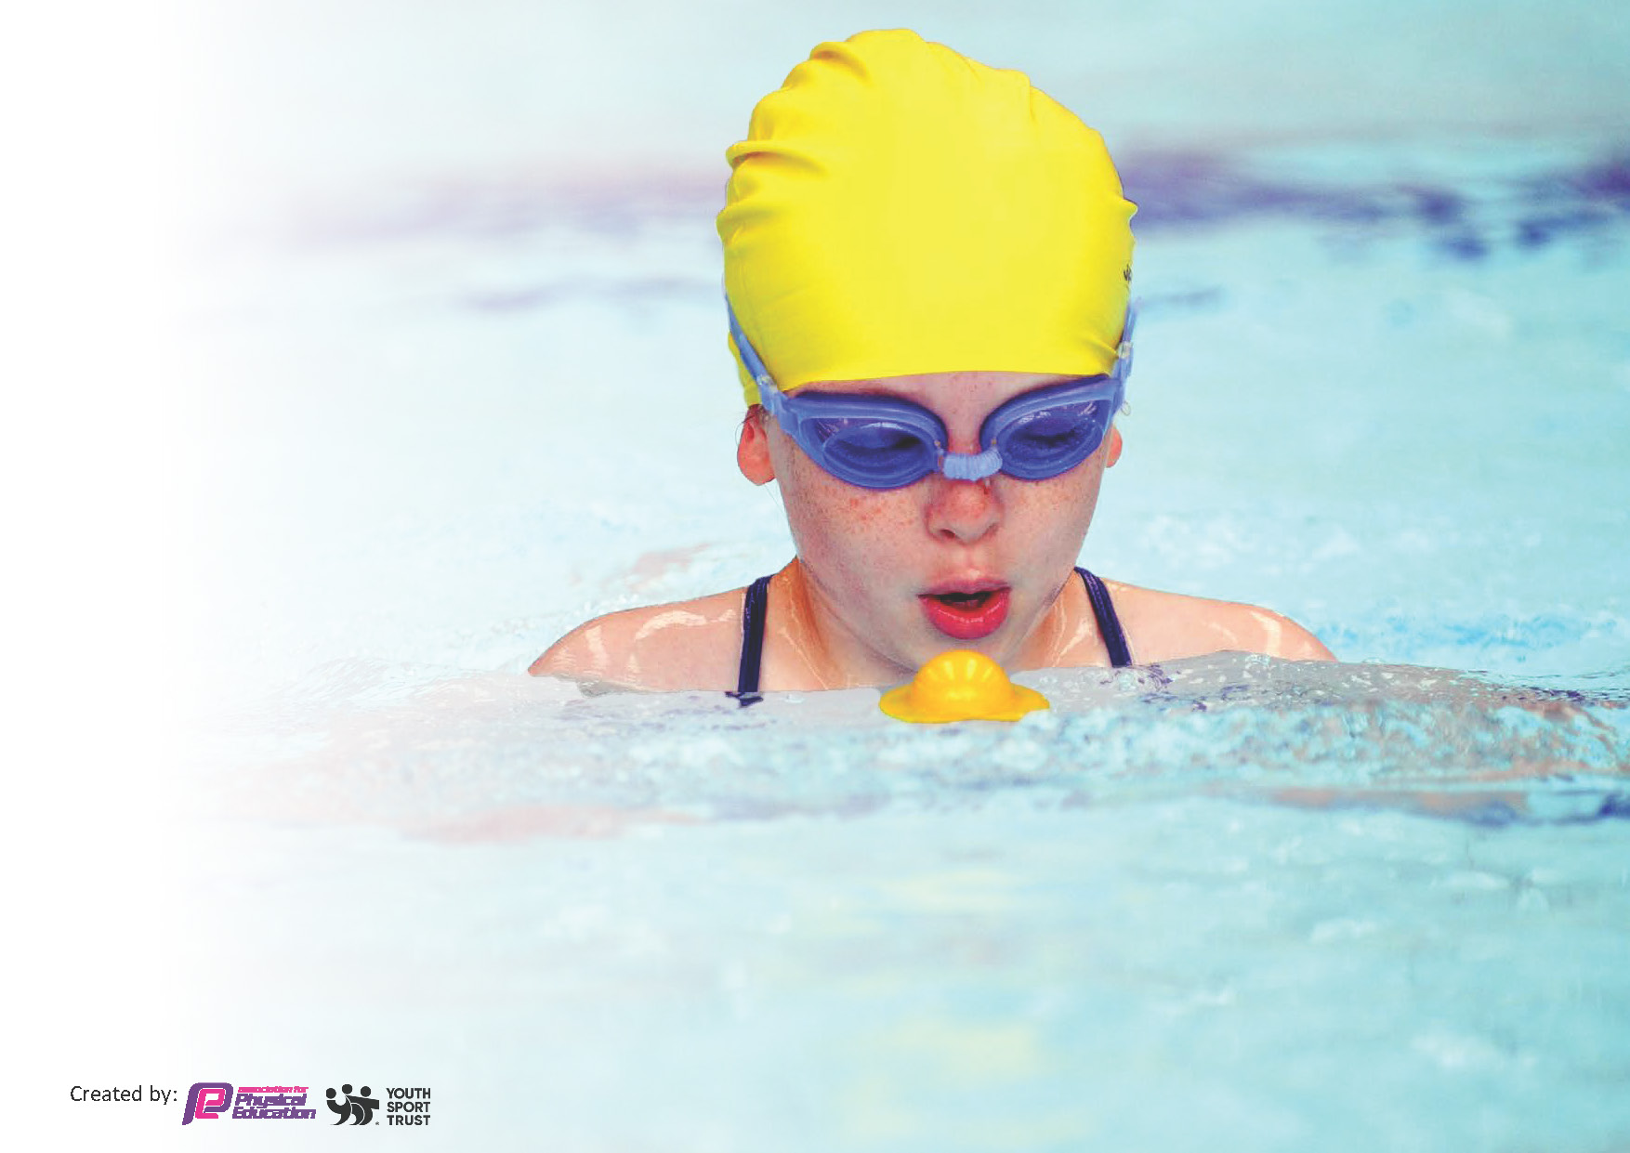
This template can be used for multiple purposes:
by:
- It enables schools to effectively plan their use of the Primary PE and sport premium
- It helps schools to meet the requirements (as set out in guidance) to publish information on their Primary PE and sport premium
- It will be an effective document to support Ofsted inspections enabling schools to evidence progress in Physical Education (PE) and evidence swimming attainment, which forms part of the PE National Curriculum. We would recommend schools consider
the Intent, Implementation and Impact of any spend, as examined within the Education Inspection Framework.

It is important that your grant is used effectively and based on school need.

Schools must use the funding to make additional and sustainable
improvements to the quality of the PE, School Sport and Physical Activity (PESSPA)
they offer. This means that you should use the Primary PE and sport premium to:

- Build capacity and capability within the school to ensure that improvements made now will benefit pupils joining the school in future years
- Develop or add to the PESSPA activities that your school already offers.

The Primary PE and sport premium should not be used to fund capital spend projects; the school’s core budget should fund these. Further detail on capital expenditure can be found in the updated Primary PE and sport premium guidance.

The Primary PE and sport premium guidance, outlines 5 key priorities that funding should be used towards. It is not

necessary that spending has to meet all the key priorities, you should select the priorities that you aim to use any funding towards.

Although completing this template is not a requirement for schools, schools are required to publish details of how they spend this funding. Schools must also outline what the impact this funding has had on pupils’ PE and sport participation and attainment and how any spending will be sustainable in the future. All funding must be spent by 31st July 2024.

The Department for Education has worked closely with the Association for Physical Education (afPE) and the Youth Sport Trust (YST) to develop this template and encourages schools to use it. This template is an effective way of meeting the reporting requirements of the Primary PE and sport premium.
Review of last year’s spend and key achievements (2023/2024)

We recommend you start by reflecting on the impact of current provision and reviewing your previous spend.

Activity/Action | Impact | Comments
Please see the attached DFE – Digital Monitoring Tool for the review of 2023/24

Key priorities and Planning 2024/25
This planning template will allow schools to accurately plan their spending.

Action – what are you planning to do | Who does this action impact? | Key indicator to meet | Impacts and how sustainability will be achieved? | Cost linked to the action
PE teaching, 1 hour 45 minutes per week, per class, including 2 year old, F1 and F2 provision.  PE teaching, 2nd Sports Leader (to maintain all classes accessing PE in manageable groups sizes on a weekly basis)  Purchasing Sports Equipment  Additional Swimming. | All children in school.  All children in school.  All children in school.  All Y6 children. | To provide QFT for PE for all pupils.  To provide sporting opportunities for all pupils, including the support of the GLD goals for F2.  To provide QFT for PE for all pupils.  To provide sporting opportunities for all pupils, including the support of the GLD goals for F2.  To replenish and provide sports equipment at the school giving high quality opportunities for exercise, movement and sport.  Extra block of Y6 swimming, in summer term, cannot be afforded from MSG. | The programme runs year on year, in itself providing the sustainable QFT of PE.  The programme runs year on year, in itself providing the sustainable QFT of PE.  The positive managing of the PE budget allows for safe and up to date equipment to be available for teaching at NPS. Widening the range of activities to include Frisbee and gymnastics in 2024/25.  Committing additional funds to enhance the PE curriculum and to support the swimming uptake in the community. | £30,541 (Cost of Teacher 4 days per week pro-rata’d down to PE teaching time  £14,103*(Cost of LM 5 days per week pro-rata’d down to PE teaching time (JC)  £2500 including PE budget and purchase of ‘soft play’ equipment for F1 to broaden delivery.  £4191.20

Key achievements 2024-2025
This template will be completed at the end of the academic year and will showcase the key achievements schools have made with their Primary PE and sport premium spending.

Activity/Action | Impact | Comments

Swimming Data 2024/25
Meeting National Curriculum requirements for swimming and water safety.
Priority should always be given to ensuring that pupils can perform safe self-rescue even if they do not fully meet the first two requirements of the National Curriculum programme of study

Question | Stats: | Further context  Relative to local challenges
What percentage of your current Year 6 cohort can swim competently, confidently and proficiently over a distance of at least 25 metres? | % | Use this text box to give further context behind the percentage.  e.g., 30% - we are struggling to get pool space due to our local pool closing so we have had to use a much smaller local school pool. We have had to limit the number of pupils attending swimming lessons during one term which means some pupils have attended fewer swimming lessons than others.
What percentage of your current Year 6 cohort can use a range of strokes effectively [for example, front crawl, backstroke, and breaststroke]? | % | Use this text box to give further context behind the percentage.  e.g., Even though your pupils may swim in another year please report on their attainment on leaving primary school at the end of the summer term 2024

What percentage of your current Year 6 cohort are able to perform safe self-rescue in different water-based situations? | % | Use this text box to give further context behind the percentage.
If your schools swimming data is below national expectation, you can choose to use the Primary PE and sport premium to provide additional top-up sessions for those pupils that did not meet National Curriculum  requirements after the completion of core lessons. Have you done this? | Yes/No
Have you provided CPD to improve the knowledge and confidence of staff to be able to teach swimming and water safety? | Yes/No

Signed off by:

Head Teacher: | Jon Crone
Subject Leader or the individual responsible for the Primary PE and sport premium: | Paul Humphreys
Governor: | Mike Potten
Date: | 2nd October 2024

