

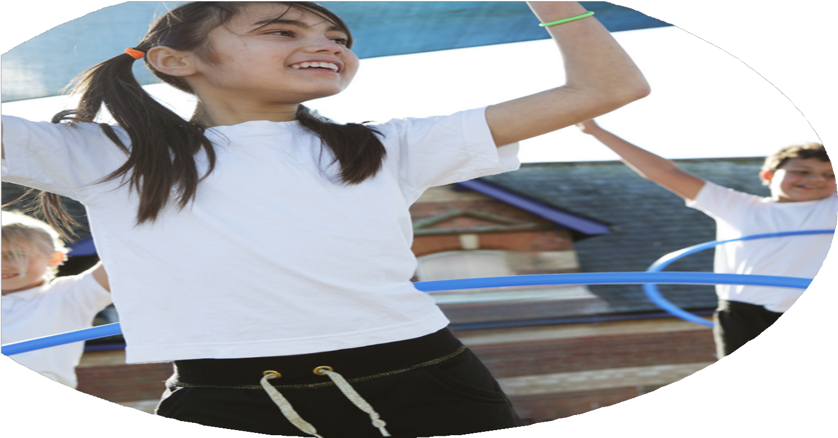
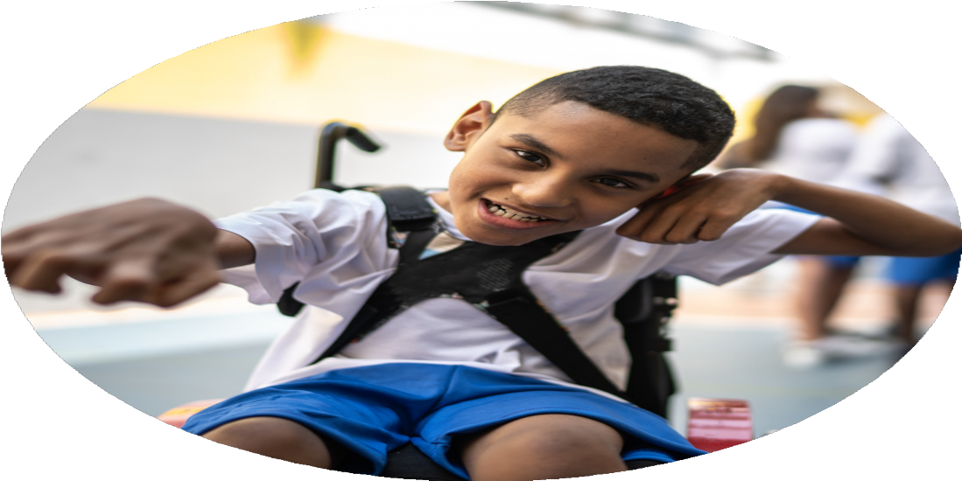
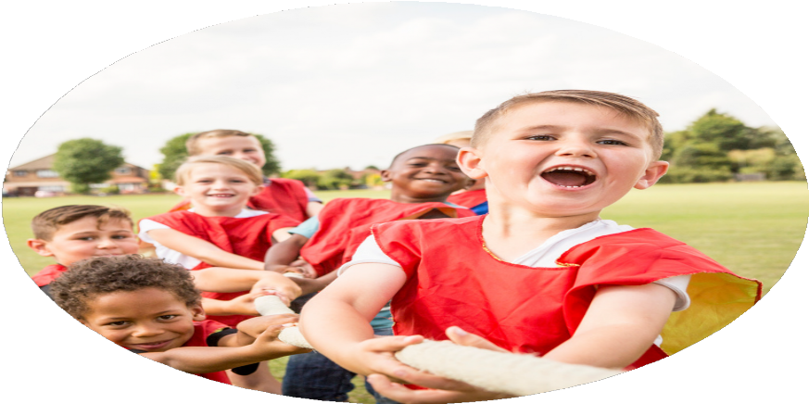



2024/25 PE Funding Evaluation Form

2025/26 PE Funding Strategy

Netherfield Primary School

Commissioned by

Created by

Images courtesy of Youth Sport Trust

PE Funding Evaluation Form

Before you decide how you are going to use the funding for this 25/26 academic year you should reflect and evaluate the impact of your use of the funding in 2024/25.
All spending of the funding must conform with the terms outlined in the Conditions of Grant document. The template is a working document that you can amend/update during the year.
Based on your evaluation of last year’s funding you should decide what you intend to do this academic year, how you will do it, and what impact you expect it to have.

It is important that the funding is used effectively and based on your school’s needs.
You must use the funding to make additional and sustainable improvements to the PE and sport in your school. You must develop and add to the PESSPA activities that your school already offers.

Summative digital reporting from June 2025 will continue to include swimming and water safety information therefore funding can be used to provide top-up lessons where necessary to ensure pupils meet national curriculum swimming requirements.

What went well | How we know | What didn’t go well | How we know
Number of children participating in extracurricular sports increased. | Tracked throughout the school, 40% of children represented the school at sport or at a sporting activity. Children were chosen to maximise experience, rather than a drive to win, although there were successes as well. | Increase in prices of resources places pressure on the ability for a school to resource PE properly. In particularly the cost of coaches (buses) to and from school swimming is extortionate and something that has to be balanced to make sure we complete our expected curriculum (Y4 swimming) and the additional swimming in Y6. | Costs increased this year, impacting on main school budget and using a larger percentage of sports premium, which has a knock on effect to other priorities.
School received the Gold Standard Sports Award for School Games. | Our commitment to attending events remains steadfast in the belief that these opportunities support the development of our children positively, particularly when looking at groups, PP, SEN, girls.

DfE 5 Key Indicators
1. The engagement of all pupils in regular physical activity.
2. The profile of PE and sport is raised across the school as a tool for whole-school improvement.
3. Increased confidence, knowledge and skills of all staff in teaching PE and sport.
4. Broader experience of a range of sports and physical activities offered to all pupils.
5. Increased participation in competitive sport.

Spend Categories Explained:
CPD  Training and development for staff to improve the delivery of PE and sport | Internal  Activities, resources, and staffing led or hosted within the school. | External  External events, providers, or competitions that enhance pupil experience.
- External training courses  - Upskilling staff to deliver swimming lessons  - Internal learning and development  - Inter-school development sessions  - Online training / resource development  - External coaches supporting confidence and competence | - School based extra-curricular opportunities  - Internal sports competitions  - Top-up swimming lessons or broadening aquatic opportunities for pupils  - Active travel  - Equipment and resource  - Membership fees  - Use of educational platforms and resources | - Activities organised by School Games organiser network  - Other inter-school sports competitions  - External coaching staff

Key Priorities | DfE Indicator Link | Actions to achieve these | Spend Category | Sub Category | Intended impact | How we will find out and know if we have intended impact
Broader experience of a range of sports and physical activities offered to all pupils | 4 | Employ specialist sports providers to give children access to sports they wouldn’t have experienced before | External | p) External coaching staff | Exposure to a wider variety of sports and increased student engagement | Survey students on new sports experienced and track participation rates
Active travel and physical activity engagement | 1 | Bikeability | External | j) Active travel | Improved cycling proficiency and increased active travel to school | Monitor number of students completing Bikeability and survey travel habits
Broader experience of aquatic activities | 4 | Provide swimming lessons for year 6 through the use of a local leisure centre and school swimming provider | External | i) Top-up swimming lessons or broadening aquatic opportunities for pupils | Improved swimming ability and water safety awareness | Assess swimming proficiency before and after lessons
Engagement in physical activity during unstructured times | 1 | Refresh/purchase of equipment for OPAL play at lunchtime to facilitate activity and for after school clubs | Internal | k) Equipment and resource | Increased physical activity during lunch and after school | Observe and record usage of equipment and participation levels
Raise profile of PE and sport across the school | 2 | Keep PE profile high within school mention in year group newsletters each half term featuring a club or sport. Competition results shared in assemblies | Internal | h) Internal sports competitions | Greater awareness and celebration of PE and sport achievements | Track newsletter mentions and assembly presentations
Engagement of less active pupils | 1 | Target less active children/ those who would benefit from additional sporting activities to attend targeted interventions, extra-curricular clubs or extra-curricular fixtures | Internal | g) School based extra-curricular opportunities | Increased participation of less active pupils in physical activities | Monitor attendance and engagement in targeted activities
Increased participation in competitive sport | 5 | Attend as many as possible of the local area games coordinator competitions, expanding the number of children experiencing out of school competition or sport | External | n) Activities organised by School Games organiser network | Broader participation in competitive sports | Record number of competitions attended and students involved
Increased access to sports clubs | 1 | Provide a significant number of free to attend after school sports clubs throughout the year | Internal | g) School based extra-curricular opportunities | Improved access and participation in sports clubs | Track club attendance and feedback from students
Increased participation in school sport fixtures | 5 | Undertake fixtures relating to school sport, entering the ‘experience’ leagues so that as many children as possible can represent the school | External | o) Other inter-school sports competitions | More students representing school in sports | Count number of fixtures and student participation

Impact we have seen | Evidence to support

